1. select SUM(total_price) AS Total_Revenue from pizza_sales

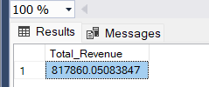

2. select sum(total_price)/count(distinct order_id) as Avg_Order_Value from

Pizza_sales

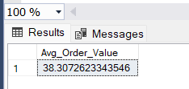

1. select SUM(quantity) AS Total_Pizzas_Sold from pizza_sales

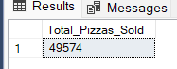

1. select COUNT(Distinct order_id) AS Total_Orders from pizza_sales

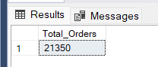

5. SELECT CAST(CAST(SUM(QUANTITY) AS DECIMAL(10,2)) /

CAST(COUNT(DISTINCT order_id) AS DECIMAL(10,2)) AS DECIMAL(10,2))

AS Avg_Pizzas_Per_Order from pizza_sales

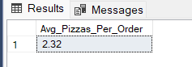

6.

Orders By WeeKDayName

SELECT DATENAME(WEEKDAY, order_date) AS DAYNAME , COUNT(DISTINCT order_id) AS Total_Orders from pizza_sales

group by DATENAME(WEEKDAY, order_date)

ORDER BY Total_Orders

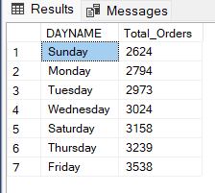

7. Orders by MonthName

SELECT DATENAME(MONTH, order_date) AS Month_Name , COUNT(DISTINCT order_id) AS Total_Orders from pizza_sales

group by DATENAME(month, order_date)

ORDER BY Total_Orders

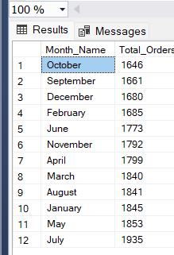

8. Percentage of sales by pizza_category  
  
SELECT pizza_category,

CAST(SUM(total_price) * 100.0 / (SELECT SUM(total_price) FROM pizza_sales) AS DECIMAL(5,2)) AS PCT

FROM pizza_sales

GROUP BY pizza_category;

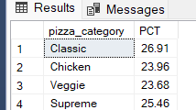

9. Percentage of sales by pizza_size

SELECT pizza_size,

CAST(SUM(total_price) * 100.0 / (SELECT SUM(total_price) FROM pizza_sales) AS DECIMAL(5,2)) AS PCS

FROM pizza_sales

GROUP BY pizza_size;

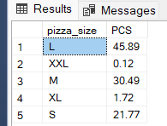

10. Total pizzas sold by category

select SUM(quantity) AS Sum_Of_Pizzas,pizza_category from pizza_sales

group by pizza_category

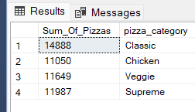

11. Top 5 best sellers by revenue

select TOP 5 SUM(total_price) AS Total_revenue, pizza_name from pizza_sales group by pizza_name order by SUM(total_price) DESC

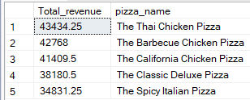

Top 5 best sellers by quantity

select TOP 5 SUM(quantity) AS Total_quantity , pizza_name from pizza_sales group by pizza_name order by SUM(quantity) DESC

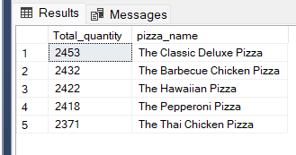

Top 5 Best sellers by orders   
  
select TOP 5 COUNT(DISTINCT order_id) AS Total_orders,pizza_name from pizza_sales group by pizza_name order by COUNT(DISTINCT order_id) DESC

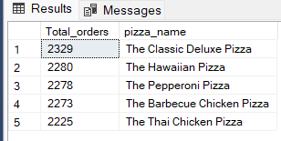

Replace DESC by ASC if we want the result to be the bottom of the values.